**Town of Hardwick, Vermont**

**Single-Jurisdiction**

**All-Hazards Mitigation Plan**

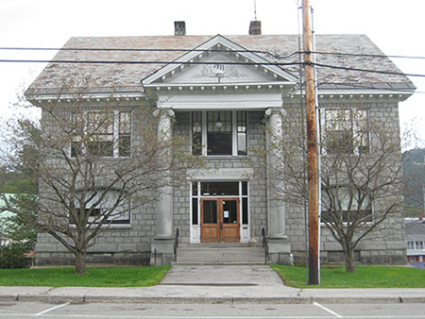

**Coordinates (Geographic Center): 72°20'W 44°31'N**

**Altitude ASL: 1,290 feet**

**Selectboard**

**Town of Hardwick**

P.O. Box 523  
Hardwick, VT 05843

03/04/2015

**Introduction**

The purpose of this plan is to assist Hardwick in identifying all of the hazards facing the town and to identify mitigation strategies to begin reducing risks from identified hazards.

Mitigation is defined by the Federal Emergency Management Agency (FEMA) as any sustained action taken to reduce or eliminate long-term risk to life and property from a hazard event. Mitigation, also known as prevention, encourages long-term reduction of hazard vulnerability. The goal of mitigation is to save lives and reduce property damage. Mitigation can accomplish this, and should be cost-effective and environmentally sound. This, in turn, can reduce the enormous cost of disasters to property owners and all levels of government. In addition, mitigation can protect critical community facilities, reduce exposure to liability, and minimize community disruption.

The Town of Hardwick, like many towns in Vermont was affected by Tropical Storm Irene and two other storm events occurring in 2011, which caused severe flooding and damages to both public and private property. After the initial emergency response and recovery to Irene, the Hardwick Selectboard started to educate themselves on hazards and to examine the town’s vulnerability and responsibility to mitigate the impact of such hazards in the future. While hazards cannot be eliminated, it is possible to determine what the hazards are and where the hazards are most severe as well as to identify local actions that can be taken to reduce the severity of the hazard.

Hazard mitigation strategies and measures alter the hazard by eliminating or reducing the frequency of occurrence, averting the hazard by redirecting the impact by means of a structure or land treatment, adapt to the hazard by modifying structures or standards, or avoid the hazard by stopping or limiting development. These strategies could include projects such as:

▪Flood-proofing structures

▪Securing propane/fuel tanks in flood-prone areas

▪Elevating furnaces and water heaters in flood-prone areas

▪Identifying and modifying high traffic incident locations and routes

▪Ensuring adequate water supply

▪Elevating structures or utilities above flood levels

▪Identifying and upgrading undersized culverts

▪Proactive land use planning for floodplains and other flood-prone areas

▪Proper road maintenance and construction

▪Ensuring critical facilities are safely located

▪Establishing and enforcing appropriate building codes

▪Providing public information

**Element A.**

**Mitigation Planning Process**

The development of this plan has followed a similar process to most community planning efforts, in addition to the Hazard Mitigation protocol established by FEMA. To start, a committee was developed to oversee the planning process, public participation, plan drafting, and finally the mitigation strategy. Following initial public input, which is described in detail below, the committee and the regional planning commission (Northeastern Vermont Development Association), researched potential hazards and assessed the risks that those hazards pose to the Town of Hardwick. They gathered initial available data and met with local officials and emergency response organizations, such as Local Emergency Planning Committee #9. Relevant plans, studies, reports and other technical information were reviewed and incorporated into the planning process as well, including:

* Hardwick Town Plan (2014)
* Hardwick Zoning ByLaws (2005), including Special Flood Hazard Regulations
* Town of Hardwick Local Emergency Operations Plan (2015)
* Town of Hardwick Flood Insurance Rate Study
* Town of Hardwick Flood Insurance Rate Maps
* Town of Hardwick Tax Maps/Floodplain Maps
* State of Vermont Hazard Mitigation Plan
* Regional Plan for the Northeast Kingdom 2006

The Committee also reviewed additional relevant data from state, federal and private resources, including:

* A list of public assistance funds spent on past disasters
* A list of state and privately owned dams (Vermont Agency of Natural Resources)
* A HAZUS study of the Town
* High accident locations (Vermont Agency of Transportation)
* Major power transmission lines (Hardwick Electric Department)
* Tier II Hazardous Materials inventory (Town of Hardwick; VT Emergency Management)
* Municipal water and wastewater treatment facilities (Agency of Natural Resources)
* Maps from the Northeastern Vermont Development Association.

**Planning Committee**

The committee includes local expertise essential to the development of the mitigation plan; in other words, community members who have a vast knowledge of natural hazards and how they affect the local community. Committee members are also able to develop, evaluate, and prioritize mitigation actions that will counteract the effects of these hazards. The Hardwick Hazard Mitigation Plan Committee includes: the Town Fire Chief, Police Chief, Hazen Union Shelter Coordinator, the Town Zoning Administrator, Several members of the Town Planning Commission, an employee of Hardwick Electric, the Town Manager and one Select Board member

**Public Participation**

The All Hazards Mitigation Planning effort was started at a public meeting of the Hardwick Select Board on December 18, 2014. Bruce Melendy, Regional Emergency Management Coordinator, NVDA, updated the Select Board and the general public.

The Town Manger explained that the Northeastern Vermont Development Association (NVDA) was awarded a State planning grant to move forward with developing an All Hazards Mitigation Plan for Hardwick and three other nearby communities. The Town Manager described the work required to complete the plan, including the creation of a public committee to work on the project, consisting of an NVDA representative, the Town Manager, a Select Board member, the Police Chief, the Fire Chief, a Rescue Squad member, and two Hardwick citizens.

**Community Profile**

**Town Background**

Caledonia County   
Chartered: August 19, 1781 (Vermont Charter)   
Area: 24,741 Acres = 38.66 Square Miles [ Size Rank: 150* ]   
Coordinates (Geographic Center): N 44° 30' W 72°22'   
Altitude: 861 feet ASL   
Population (US Census, 2010): 3,010 [ Population Rank: 54* ]   
Population Density (persons per square mile): 77.9 [ Density Rank: 50*

Hardwick is a small, rural community located in Northeastern Vermont that was chartered on August 19, 1781, (see Hardwick Base Map). The Town of Hardwick abuts seven towns; Greensboro, along the Northeastern Border, Walden along the Southeastern Border, Woodbury along the Southwestern border, Wolcott and Elmore along the Northwestern Border, Stannard touches the Eastern corner and Cabot touches the southern corner. The town also abuts three counties; Orleans, Lamoille and Orange.

The Town of Hardwick has two unincorporated villages, Hardwick Village and East Hardwick. Hardwick Village was once an incorporated village but was disincorporated in 1988. The former Hardwick Village area is characterized by dense development, including single family and multifamily dwellings and various commercial and industrial businesses. The East Hardwick area is much smaller and it is mostly single-family homes, with a few multifamily dwellings and a few commercial buildings.

In the late 1800s, Hardwick was a center of industry, with several factories and productive granite quarries. As time passed, many of the mills closed or changed use and the quarries ceased operation. In the last decade, there has been a boom in industries involved in the processing of agricultural products. The industrial park is nearly full, mostly with agricultural processing facilities, including Vermont Soy, the Sugar Man, the Vermont Food Venture Center, Vermont Natural Coatings, and Caledonia Spirits. The rest of the town is sparsely populated and except for a few commercial businesses, the lands are used primarily for agriculture and forestry purposes.

The Town of Hardwick is part of the Orleans Southwest Supervisory School District, which provides K-12 public education. The town has two public schools. The Hardwick Elementary School serves grades K - 6 grades. The 2014 enrollment is listed at 243 with a capacity of 360 students. The Hazen Union School serves grades 7 – 12. The 2014 enrollment is listed at 368 students with a capacity of 500 students. There are two preschools in the town, one is located in the Southwest corner of Town off from Route 14 at 49 Winter Street and the other is Head-start located on 67 Church Street. .

**Topography & Climate**

The Western portion of the town is characterized by steeper slopes and higher elevations, while the eastern portion of the town is lower rolling hills. Most of the bedrock is covered with glacial deposits of varying depths.

The climate in Hardwick is much the same as in the rest of northern Vermont. The following climate data comes from NOAA’s recording station in nearby Morrisville, Vermont. The average coldest winter temperatures occur in January, with an average mean temperature of 13.2 degrees and an average nighttime lows of 24.9 degrees. The warmest part of the year is in July, with an average mean temperature of 65.7 degrees and an average daytime high of 77.8 degrees Fahrenheit.

The wettest time of the year occurs during July and August with averages of 4.61 inches and 4.38 inches of rain, respectively. The driest period is January through March with average melted precipitation amounts of 2.66 inches in January, 2.59 inches in February and 2.79 inches in March. The bulk of the snow falls in December, January, February and March with 25.0 inches, 21.9 inches, 21.6 inches and 21.8 inches respectively. The average total snowfall for the year is 104.2 inches. October and November average 0.8 inches and 8.4 inches of snow, respectively, with April receiving 4.7 inches.

**Town Infrastructure**

The Town of Hardwick has 1.5 miles of Class 1 roads, 11.3 miles of Class 2 Roads, 52.5 miles of Class 3 Roads, 5.7 miles of Class 4 Roads, and 16.1 miles of State Highway. Much of Main Street was repaved in 2012 and 2014. The Town has a 5-year road plan that includes yearly paving projects. Additionally, the Town of Hardwick has developed a long range plan and a line item allocation in its Capital Budget to refurbish troublesome portions of the Town’s Class 3 or dirt roads, which make up the majority of Hardwick’s roads. All major bridges located in Hardwick are reviewed by the Agency of Transportation regarding their structural needs and the Town makes improvements to these bridges annually as necessary. The Town also maintains a culvert record system that tracks the location, condition and installation date of all Town road culverts.

The Town of Hardwick owns its own power company, the Hardwick Electric Department, which provides power to 5 communities in 3 different counties. There are two dams located in the Town. The Mackville dam is located on Nichols Brook on the southeast side of town and was rebuilt in 2004. The Jackson dam is located on the Lamoille River on the southwest side of town downstream of downtown and the industrial park. Neither of these dams provide electrical generation. There is no electrical generation in the Town of Hardwick aside from solar voltaic panels and wind generators which are all owned by private individuals.

There are two cell towers located in Hardwick, one on Hopkin Hill on the Claire and Rod Mayo farm and one located off from Bridgman Hill on the Wendell and Beverly Shepard Farm.

The Hardwick Community Water Supply system has two wells that supply all of the water used by the village of Hardwick. The municipal wells are located near the Hardwick Industrial Park adjacent to Wolcott Street. The East Hardwick Fire District #1 supplies water to the village of East Hardwick from springs located on Ward Hill to the south. The Town has well head protection areas and plans for providing water in case of a shortage due to unexpected circumstances. Private wells are not permitted within the water distribution area of the Urban Compact.

The Urban Compact of the Village of Hardwick, now the Town of Hardwick, is served by a tertiary wastewater treatment facility built in 1978. The facility has been upgraded three times since its initial construction to increase capacity and to provide a higher level of wastewater treatment. Private septic tanks and leach fields are allowed outside of the collection area of the Hardwick Urban Compact.

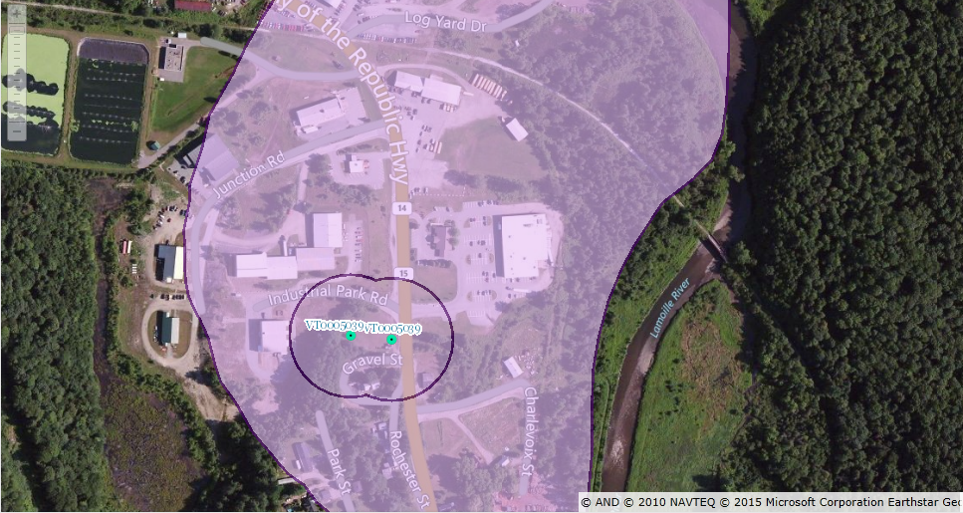

**Hardwick Water Wells & Ground Water SPA VT0005039**

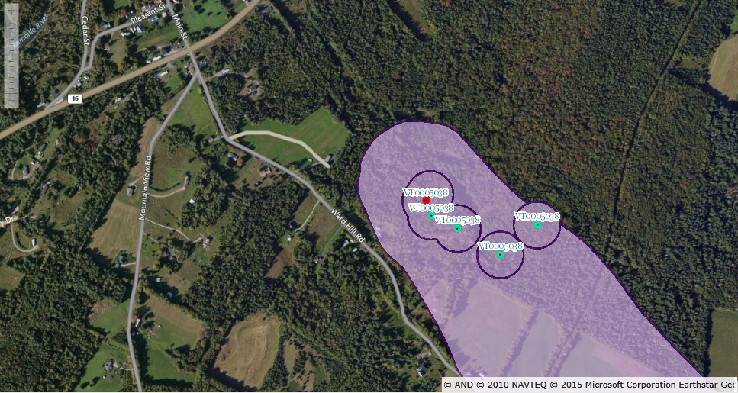

**East Hardwick Fire District #1 Springs & Ground Water SPA VT0005038**

.

**Town Emergency Services**

**EMS Services -** Town emergency medical services are provided by a local nonprofit organization known as the Hardwick Rescue Squad (HRS). HRS serves the towns of Hardwick, Craftsbury, Greensboro, Wolcott, and Woodbury. The HRS has its headquarters collocated on Creamery Street with the Hardwick Town Garage.

**Town Fire Department -** The Town has a well-trained volunteer fire department with up-to-date equipment including a ladder truck, a tanker truck and a brand new rescue pumper truck. South Main Street in Hardwick Village has seen four significant downtown fires in the last 20 years, one of which resulted from an automobile crashing into a building. Much of the new construction on this street now includes new sprinkler systems and firewalls between structures.

**Town Police Department -** The Hardwick Police Department consists of seven full-time officers and two part-time officers. The Town has four police cruisers and a K9 officer. The Police Department moved into new quarters in 2013 located on 54 High Street in Hardwick. The Hardwick Police Department provides services to the Town of Greensboro and to the Town of Hardwick.

**Element B.**

**Hazard Inventory and Risk Assessment**

**Methodology**

A vulnerability analysis for Hardwick began with an inventory of possible hazards and an assessment of the risks that they pose. The inventory was a first step in addressing the questions: What hazards can affect your community? How bad can it get? How likely are they to occur? What will be affected by these hazards? How will these hazards affect individuals? The magnitude of the impact of the hazard was defined as follows:

* Negligible: less than 10% of properties damaged/minimal disruption to quality of life.
* Limited: 10% to less than 25% of properties damaged/Loss of essential facilities/services for up to 7 days/few (< 1% of population) injuries possible.
* Critical: 25% to 50% of properties damaged/Loss of essential facilities/services for > 7 days < 14 days/Major (< 10% of population) injuries/few deaths possible.
* Catastrophic: More than 50% of properties damaged/loss of essential facilities/services for > 14 days/Severe (> 10% of population) injuries/multiple deaths possible.

The frequency of occurrence was classified as shown:

* Unlikely: less than 1% probability in the next 100 years.
* Possible: 1% to 10% probability in the next year, or at least one chance in the next 100 years.
* Likely: 10% to 100% probability in the next year, or at least one chance in the next 10 years.
* Highly Likely: Near 100% probability in the next year.

Additional considerations include seasonal patterns, areas likely to be most affected, probable duration of the hazard, and speed of onset.

A combination of the impact and frequency of the hazard was used to classify the community vulnerability as HIGH, MODERATE or LOW. For example, a flood event is highly likely in many communities but the degree of impact varies. A highly likely flood with critical or catastrophic impact rates the community vulnerability as HIGH. Another community with a highly likely or likely flood with a limited impact would receive a vulnerability rating of MODERATE. The vulnerability of a community having the occurrence of an event as possible or unlikely with limited or negligible impact would be classified as LOW.

**Profiling Hazards**

For hazard profiling some hazards from the table above were grouped for analysis purposes. For example, the Severe Weather category includes tornado, hurricane, high winds, and winter storm/ice. These subcategories are indicated in bold lettering throughout the following detailed hazard profiling section. Less significant hazards did not have occurrence frequencies or levels of impact that would necessitate a more detailed level of analysis. Human losses are not calculated as part of this exercise, but could be expected to occur depending on the type and severity of the hazard. Potential loss estimates are based on vulnerability and risk discussions held during the Hazard Mitigation Review Committee meetings.

1. **Weather Threats - Overview**

The National Weather Service (NWS) in Burlington describes the weather affecting Caledonia County in the following manner. The weather across Caledonia County can be quite variable and each season has its’ own particular hazards. Moisture from the Atlantic Ocean, Gulf of Mexico and Great Lakes combines with warm air from the southern USA and bitter cold air from Canada to form a volatile mix.

During the winter months, roughly from November through March, heavy snow frequents the area. Storms in the early and late part of the season exhibit a tendency for heavy, wet snow. This can lead to power outages. Also, early season storms may be elevation dependent, with snow in mountainous areas and rain in the valleys.

Another aspect of winter is ice jam flooding and the Town has experienced significant ice jams on the Lamoille River in the past. After substantial ice forms on the rivers, several days of unusual warmth coupled with rainfall can lead to ice breakup. The chunks of ice form jams which cause localized flooding on rivers. Ice jams are most prevalent during the January thaw (late January) as well as in March and April during (Hardwick has ice jams in) the spring thaw on the Lamoille River. In 1994, with the engineering assistance from the US Army Engineer Research and Development Center of the Cold Regions Research and Engineering Laboratory (CRREL), the Town installed sloped granite ice control structures in the riverbed of the Lamoille River just east of the Village area to help retain ice floes in order to prevent ice jams and flooding further down the river. The structures have been very effective controlling ice on the east side of the village (by controlling ice) upstream of the Village and adjacent to Route 15. The Town occasionally expends local tax dollars as a preventative effort to break up the ice jams on the west side of the village. The Town experienced minor ice-related flooding along Wolcott Street in 2010 and in 2014.

Finally, while ice storms can be expected annually, a large ice storm event such as the January 1998 storm that wreaked havoc on northern New England and Quebec, Canada is infrequent. This type of storm forms when the lower levels of the atmosphere and the ground are at or below freezing, but rain is falling through warmer air aloft. The water freezes at the lower levels on trees, power lines and roads leading to (and causes) power outages and disruptions in everyday life. More common are the light events of freezing rain or mixed precipitation. Local town road crews are very efficient with sand and salt when weather warnings trigger extra attention to roads. Ice and snow events have caused damage in Hardwick, but generally damage has been less than experienced elsewhere in the State. The last ice storm event occurred in December 2014 and cost the Hardwick Electric Department approximately $45,000 for repairs

In the spring the County may have flooding due to heavy rain. Towards the end of spring, the convective season is likely to begin and severe thunderstorms are a possibility.

During the summer, convective weather is the main threat. This includes locally strong straight line or downburst winds from thunderstorms. Also lightning can be a killer, and can strike up to 15 miles outside the parent storm. It does NOT have to be raining in your area to be at risk for a lightning strike. Tornadoes, while very rare in Vermont, can occur. Vermont tornadoes tend to be small, weak and short-lived. Typical damage includes downed trees and power outages.

During the summer months, flooding tends to be more of the flash flood type of event. Thunderstorms may form or move over mountainous areas or river basins and drop copious amounts of precipitation. Water on rivers and streams rises rapidly in a period of six hours or less and the main stem rivers can flood as well as the smaller streams.

During the fall there are several weather threats. Strong storm systems move from the Ohio Valley through the Great Lakes and into Canada. As these storms move into Canada, the associated cold front then moves across our area with strong west or northwest winds and colder air. Heavy rain may accompany these storms.

Another threat in the fall is the remnants of Tropical Storms. These systems, while not generally impacting us with Hurricane force winds, can result in Gale force winds and very heavy rains. These conditions can lead to power outages as trees and power lines are blown down. These storms can also result in major flooding. Tropical Storm Chantal in 1989, Tropical Storm Dean in the mid-90s, Tropical Storm Floyd in 1999, and Tropical Storm Irene in 2011 all impacted the area. Damages due to storm events experienced from 2011 to date were approximately $420,000, of which $10,000 was paid by FEMA, $350,000 by Federal Highway funds, and $60,000 by property and casualty insurance to the Town of Hardwick.

Thus, the two hazards that can happen any time of year are flooding and high winds. Any weather hazard mentioned above may combine with a manmade disaster such as a hazardous material spill. Other weather threats in Hardwick would include extreme heat and cold conditions which especially affects the very young and old. Early and late season frost and freeze conditions can adversely impact agricultural interests.

Finally, when discussing natural hazards, one should not forget the possibility of earthquakes. A HAZUS Analysis was completed by the Vermont Agency of Natural Resources, Department of Environmental Conservation. It concluded that while earthquakes are not uncommon in Vermont and the surrounding geographic areas, the likelihood that a large earthquake would cause major havoc within the region is slight.

1. **Flood/100-Yr Flood/Flash Flood**

Floods can damage or destroy public and private property, disable utilities, make roads and bridges impassable, destroy crops and agricultural lands, cause disruption to emergency services, and result in fatalities. People may be stranded in their homes for a time without power or heat or they may be unable to reach their homes. Long-term collateral dangers include the outbreak of disease, loss of livestock, broken sewer lines or wash out of septic systems causing water supply pollution, downed power lines, loss of fuel storage tanks, fires and release of hazardous materials.

The National Weather Service issues flood watches and warnings when conditions are right for flooding. A flood watch indicates that meteorological conditions are conducive to flooding. People in the watch area are instructed to stay tuned to local radio or television stations for updates on flooding and weather conditions. When flooding is imminent, a flood warning is issued. The warning will identify the anticipated time, level and duration of flooding. Persons in areas that will be flooded are instructed to take appropriate protective actions, up to and including evacuation of family members and removal or elevation of valuable personal property

Inundation-related flood loss is a significant component of flood disasters; the more common mode of damage is associated with the dynamic, and oftentimes catastrophic, physical adjustment of stream channel dimensions and location during storm events. These adjustments are often due to bed and bank erosion, debris and ice jams, or structural failure of or flow diversion by man-made structures. A greater threat is erosional damage. The state of Vermont has been conducting geomorphic assessment to identify areas vulnerable to erosional damage.

A section of the Lamoille River flows through town, including the “village” area. Hardwick has received digital GIS FIRM data, allowing for greater analysis of flood risks.

Flood risk information presented on FIRMs is based on historic, meteorological, hydrologic, and hydraulic data, as well as open-space conditions, flood control works, and development. To prepare FIRMs that illustrate the extent of flood hazard in a flood prone community, FEMA conducts engineering studies referred to as Flood Insurance Studies (FISs). Using information gathered in these studies, FEMA engineers and cartographers delineate Special Flood Hazard Areas (SFHAs) on FIRMs. SFHAs are those areas subject to inundation by a flood that has a 1-percent or greater chance of being equaled or exceeded during any given year. This type of flood is referred to as a base flood. A base flood has a 26-percent chance of occurring during a 30-year period, the length of many mortgages. The base flood is a regulatory standard used by Federal agencies, and most states, to administer floodplain management programs, and is also used by the National Flood Insurance Program as the basis for insurance requirements nationwide.

Of all types of natural hazards experienced in Vermont, flash flooding has historically resulted in the greatest magnitude of damage suffered by private property and public infrastructure. Most communities have undertaken significant mitigation measures in recent years. However, flash floods can strike at any time in areas that are not identified as typical flood hazard areas, and thus they continue to cause public and private damage. Flash flooding has been more frequent in Hardwick since the last Hazard Mitigation Plan was updated in 2005, with three separate (different) events during 2011 and one in 2012. The events of 2011 resulted in the Johnson property located at 68 Church Street being declared uninhabitable and did great damage to roads in Hardwick.

Major roads and highways, Class One and Two, are governed and maintained by the Vermont Agency of Transportation, or VTRANS, and their highway district #7 covers the Town of Hardwick. Many of these Class Two roads experience flooding during flash floods, and as a result maintenance and repair of this infrastructure has been ongoing. VTrans staff has worked with the Town of Hardwick to adopt Local Codes and Standards as a best practice. The standards require upgrades on new roads, culverts and bridges to help withstand local flood related damages.

The Flood of 1927 is the one major flood event against which all others are judged due to the severe loss of life and property that was experienced. More than 50% of bridges and roads statewide were damaged in the flooding on November 27th . Most of Vermont’s present bridges over rivers were installed after that flood and are now being methodically replaced by the Vermont Transportation Agency on state roads and highways.

1. **High Winds, Hurricanes, and Tornadoes**

High winds can result from hurricanes, tropical storms (covered under flooding), summer thunderstorms, and tornadoes. The State of Vermont Emergency Operations Plan states that hurricanes and tropical storms are rare events in our region and that high winds are most commonly the result of severe summer thunderstorms. Damage from summer thunderstorms in our region is limited in both scope and cost. The following table describes the damage extent of different wind speeds:

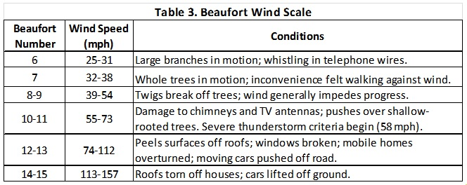

High wind events such as tornadoes and hurricanes are uncommon events in Hardwick; therefore, aside from the data shown below, there is an acknowledged lack of previous occurrence data.

1. **Winter/Ice Storms**

Hardwick experiences a few heavy snow events each year and the town maintains a fleet of snow removal equipment to deal with these storms. Additionally, to minimize the number of falling trees due to snow/ice loading which can impinge on town highways and electrical infrastructure, the public works department, does routine tree and branch removal along Town highways and power lines.

1. **Hazardous Materials and Highway Incidents**

Hazardous materials accidents can occur anywhere there is a road, rail line, pipeline or fixed facility storing hazardous materials. These materials are poisonous, corrosive, flammable, and radioactive or pose other hazards. Almost the entire County is at risk for such an unpredictable accidents. Most accidents are small spills and leaks, but some result in injuries, property damage, environmental contamination and other serious consequences.

Emergencies involving hazardous materials can be expected to range from a minor accident with no off-site effects to a major accident that may result in an off-site release of hazardous or toxic materials. The overall objective of chemical emergency response planning and preparedness is to minimize exposure for a wide range of accidents that could produce off-site levels of contamination in excess of Levels of Concern (LOC) established by the U.S. Environmental Protection Agency. Minimizing this exposure will reduce the consequences of such (an) emergencies to people near facilities which manufacture, store and process hazardous materials.

Large volumes of hazardous materials are transported to and through the County by railroad and highway daily. Within Caledonia County there are a number of public and private fixed facilities that produce or use hazardous materials. In Hardwick, the following facilities produce, use or store hazardous materials on site[1]:

The following is a list of facilities likely to have stored hazardous materials and pose some risk of a spill or of environmental contamination.

1. **Transportation Corridors** – That go through the village of Hardwick’ Source Protection Area are Vermont State Highways 14 & 15, five Town Roads, and a small section of the former Lamoille Valley Railroad. These transportation routes have an asphalt surface. The Lamoille Valley Railroad tracks were removed by the State Agency of Transportation in 2005 and the surface is now crushed stone and gravel. The Town roads are properly drained in a manner to prevent siltation. Additionally, there are dirt driveways leading to homes, businesses, to the municipal pump house and to the wastewater treatment facility. Waste and other smaller haulers do use these roads. The State of Vermont and the Town have discontinued salting a 1,500' section of Routes 14 & 15 by the well house. The greatest threat to the contamination of the water supply is through the possibility of an accident or spillage of materials hazardous to a potable water supply. The Town has very little control over potential accidents. Signs have been posted notifying motorists of the Town of Hardwick's Water Supply Well Protection Area. In East Hardwick, the Source Protection Area is overlain by forest and farm fields. The above mentioned railroad does cross the SPA and Ward Hill Road skirts a portion of its southwest edge, but this road is lightly used for mostly local traffic.

2. **The Vermont Food Venture Center** consists of a small cheese plant and several food preparation kitchens. The cheese plant uses caustic soda and a mixture of hypochlorite and hydroxide compounds for cleaning and disinfection. The chemicals are stored in 50 gallon carboys, with no more than two 50 gallon carboys of each of the chemicals on hand at any one time. The food preparation kitchens are cleaned and disinfected using quaternary ammonia and hydroxide/hypochlorite chemicals. These two chemicals are stored in 4 gallon containers with no more than 12 gallons onsite at any one time. All chemicals are stored inside the building.

3. **Vermont Soy, Hardwick Enterprise Group –** produces food products manufactured from soy, such as soy milk and tofu. Cleaning compounds consist of ammonium chloride, nitric acid, and a mixture of hydroxide and hypochlorite. These chemicals are stored in quantities of 5 gallons or less. All chemicals are stored inside the buildings.

4. **Caledonia Spirits and Honey Gardens Winery –** Produce distilled alcohol and wine products. They use a combination of phosphoric acid/nitric acid for pH adjustment and citric acid for cleaning, sanitizing. There is no more than 1-2 gallons of any of these chemicals stored at the plant at any one time, and all are stored inside the building.

5. **Service Stations/Gas Stations/Underground Storage** - There are two businesses in Hardwick Village that have large underground storage tanks: 1 - 3,000 gallon gas tank and a monitoring well - these tanks are all currently empty; Perry Global has 1 - 20,000 gallon gas tank; and Lamoille Valley Ford has 1 - 4,000 gallon gas tank. In East Hardwick, D&L Beverage & Deli sells gasoline and diesel fuel from underground tanks: Hardwick Motors, Greensboro Garage, Rowell Brothers, Dona’s Car Store, Lanphear Sales and Services, Hay’s Auto Repair, and Hill Group of Vermont Garage are all service stations that wash and repair vehicles and other small machinery. Each shop has oil-based materials stored on site, though not in large volumes.

6. **Auto Parking** - Most of the businesses have parking lots. The Grand Union/Brooks Plaza has the biggest parking lot and can hold approximately 75 cars. Cars are parked near all residences and have the potential of leaking fluids which could be hazardous to local water resources.

7. **Fuel Storage** - Many residences have concrete basements with 275 gallon fuel oil tanks which are regularly filled by one of three local oil companies. A few of the basements have earthen floors with no containment. Several homes have outdoor above ground fuel tanks. According to representatives of the fuel supply companies, they would have a very good idea of the use of oil and they believe that they would know if there was any leakage from customer tanks. They have informed us that they are required to notify the Owners if they suspect a leak and have promised to notify the town as well in an effort to prevent problems. Additionally, Bourne Energy has an above ground fuel storage tank located on Log Yard Road in the Pudvah Industrial Park. This tank is used to refuel log trucks that deliver logs for storage on Log Yard Road. Its volume is equal to 2,000 gallons. This tank is protected by secondary containment.

8. **W.E. Aubuchon/Poulin Lumber** - W.E. Aubuchon is a hardware/grain store. The premises sell a number of paints, fertilizers and other hardware products. These materials are all stored inside the building. Poulin Lumber sells much of the same contents that W.E. Aubuchon currently sells. The Town will be made aware if there is leakage of any substantial product. Chemicals are stored inside buildings.

9. **Hardwick Waste Water Treatment Plant** - The Sewer Plant has two - 5 million gallon lagoons, 300 gallons of 12% hypochlorite, 220 gallon of 38% Sodium Bisulfate, 1000 gallon #2 fuel oil underground, and a 275 gallon diesel tank in the basement. The Town of Hardwick tests periodically for leakage of the lagoons through two monitoring wells. All chemicals are stored inside the control buildings at the water pollution control facility.

**ANR Solid Waste Records**

There are no permanent solid waste receiving or handling facilities within the Hardwick Urban Compact. All Metals Recycling and Gates Salvage yard are located in Hardwick, but are outside of the Urban Compact South West of the Village.

**ANR Hazardous Waste Records**

A 2012 review of the Agency of Natural Resources website of Vermont Hazardous Waste Sites identified the following sites within the Town’s Urban Compact.

* Kwikstop #870082, not active, remediation complete
* House of Pizza #941602
* Hardwick Motors Inc. #962091 (now Lamoille Valley Ford)

The following sites are located in the Hardwick, but may be outside the urban compact and are not located in the Town water supply Source Protection Area.

* Hardwick Electric #770105, active
* Hay’s Texaco #880229, active
* Ed's Deli #900490, active, (now called D & L Beverage)
* Brochu's Citgo #890439, active
* Perry's Oil #941608, active
* Green Mountain Sanitation #951792, active
* Barcomb Auto Sales #992671, active
* Mike's Gulf #880223, active
* Hay's Convenience #880229, active
* Gates Salvage #20033117, active

**ANR PERMITTED WASTEWATER SYSTEM**

The Town of Hardwick operates an aerated lagoon wastewater treatment facility that discharges tertiary treated, disinfected and dechlorinated wastewater to the Lamoille River.

**RANKING OF ACTIVITIES**

Most Risk 1 Transportation Corridors

2 Service Station/Gas Station/Underground Storage

3 Vermont Quality Dairies

4 Auto Parking

5 Fuel Storage

6 W.E. Aubuchon Hardware/Poulin Lumber

Lowest Risk 7 Hardwick Waste Water Treatment Plant

Mishandling and improper disposal or storage of medical wastes and low-level radioactive products from medical use are also a hazard to Caledonia County towns.

Community vulnerability is difficult to assess due to the nature of the incident. The next section lists the incidents that have occurred in the County since 2000. Most are considered minor fuel spills that are most likely to happen in the region.

Hazardous materials pose a risk to a large area of the town because of major east/west and north/south corridors: VT Routes 15, 14, and 16. Accidents are common, especially in the village center and occasionally involve commercial trucks, especially along Routes 14, 15, and 16. The municipal water supply just west of the village and along Route 15 is particularly vulnerable to accidents involving hazardous material spills. The traffic speeds within the urban compact are 25 to 30 MPH, which reduce the impact of traffic accidents in the higher population areas.

Traffic Related Hazards

The table below lists the High Accident Locations (HALs) for the Town of Hardwick for the last five (5) years

.



These are repetitive accidents and not necessarily related to hazardous materials. The HAL table indicates areas that may be considered a high threat should a vehicle carrying hazardous materials be involved in an accident. More precise data is available in a full report entitled the Vermont Crash Reporting System (CRS) by the Vermont Agency of Transportation.

1. **Structure Fire**

Structure fires were identified in the hazard vulnerability assessment as a “high” risk to the town due to their high probability of occurrence. Structure fires are common throughout Vermont during the winter months and such fires may result in loss of property and/or life. They can affect a single residential structure or spread to other homes, businesses, or apartment complexes. Residential fires kill more people in the U.S. each year than all other natural disasters combined.

In Vermont there were 3,089 fires reported in 2010, 64% of which were structural fires. These fires resulted in 4 civilian deaths and amounted to over 18.5 million dollars in estimated property losses. With an average housing unit value of $137,500 according to American Community Survey data for 2006-2010, damage from structural fires could result in significant costs to the Town of Hardwick.

The fire department data reflects the hazard that structure fires pose in the town and throughout the region. The most significant common factor in fire fatalities in Vermont continues to be the absence of a functioning smoke detector in the sleeping area of residential structures. Fires can be caused by improperly disposing of ashes with live coals from wood stoves, ignition of creosote buildup in chimneys, or faulty electrical wiring.

Wildfires are relatively rare in the state of Vermont. The State Hazard Mitigation Plan’s analysis of wildfire threat states that “Wildfire conditions in Vermont are typically at their worst either in spring when dead grass and fallen leaves from the previous year are dry and new leaves and grass have not come out yet, or in late summer and early fall when that year’s growth is dry”. The 2010 Fire Marshal Report states that Caledonia County experienced 5 wildfires in 2010 resulting in 6.7 acres of damage; historic data is listed below:

* 2006 – 7 wildfire calls (3.4 acres damaged)
* 2007 – 12 wildfire calls (8.3 acres damaged)
* 2008 – 3 wildfire calls (2.5 acres damaged)
* 2009 –13 wildfire calls (3 acres damaged)

Given the historical data available, it is anticipated that small brush fires will continue to occur throughout the Town of Hardwick at an average rate of approximately 5 per year based on previous data. However, given the appropriate seasonal conditions and Hardwick’s large contiguous forest parcels, the threat of a large wildfire remains.

This is currently the best level of detail for fire history within the Town of Hardwick. The future plan update process as outlined in the Planning Process section at the beginning of this plan calls for additional local meetings and input during the next plan revision. During these meetings, NVDA staff, the Town of Hardwick, and the Hardwick Volunteer Fire Department will collaborate to develop a more comprehensive history of fire events. Additional data resources, including the Vermont State Archivist, and local town knowledge will be utilized to ensure the comprehensiveness of historical data.

1. **Dam Failure**

There are two hydro-electric dams in Hardwick. The Mackville dam was completely rebuilt in 2000. This dam is located Southeast of Town. HED is required to maintain safety checks, inform the public of inundation plans, and have an early warning system in place. Regular maintenance is ongoing to assure safety measures. Should a large flood event occur beyond the magnitude of the historical past of the region, the possibility exists for a major breach of a dam and severe inundation throughout the downstream areas. A well-situated, higher magnitude earthquake could also cause severe damage to dams. There are no other dams located within the Town of Hardwick.

1. **Water Supply Contamination**

A review of quarterly Consumer Confidence Review of drinking water quality has revealed no incidents of contamination. Due to occasional water main breaks, there have been short-term boil water notices.

|  |  |  |  |  |
| --- | --- | --- | --- | --- |
| **Possible Hazard** | **Likelihood** | **Impact** | **Community Vulnerability** | **Most Vulnerable** |
| Tornado | Low | Medium | Low | Structures |
| Flood | High | Medium/ High | High | Infrastructure |
| Flash Flood | High | High | High | Infrastructure |
| Hazardous Materials | Medium/  High | High | Medium/High | Roads, water supply |
| Radiological Incident | Low | High | Low | Residents |
| Structure Fire | High | High | Medium | Downtown, residences |
| Power Failure | Medium | High | Medium | Residences, businesses |
| Winter Storm/Ice | High | Medium | Medium | Residences, businesses |
| High Wind | Medium | Medium | Medium | Loss of power |
| Air crash | Low | Low | Low | Site specific |
| Water Supply Contamination | Medium/  High | High | High | Public water supply, rivers |
| Hurricane | Low | Medium | Low | Power lines, residences |
| Earthquake | Low | Medium | Low | Site specific |
| Dam Failures | Medium/  High | High | Medium/High | Residences, businesses, infrastructure |
| Drought | Low | Medium | Low | Water supply |
| Chemical or Biological Incident | Low | High | Low | Site specific |
| Highway Incidents | Medium | Medium | Medium | Site specific |
| Wildfire/Forest Fire | Medium | Medium | Medium | Farms, sugar bushes, residences |
| Landslide | Low | Medium/  Low | Low | Site specific |
| School Safety Issues | Low | Medium | Medium | Students, teachers, hostage issues |
| Terrorism | Low | Medium | Low | Residents, businesses, local officials |

**Element C.**

**MITIGATION STRATEGY**

**Existing Hazard Mitigation Programs, Projects & Activities**

The following policies, programs and activities related to hazard mitigation are currently in place and/or being implemented in the Town of Hardwick.

The town currently participates in the NFIP program and will continue to regulate floodplain use through the Hardwick Zoning Bylaw and application regulations concerning floodplain development which were adopted on 05/17/2012. These regulations are enforced using the FEMA FIRMs maps last revised in 07/17/2002. The ongoing enforcement of these regulations maintains the town’s compliance with the NFIP with the Hardwick Zoning Administrator being the ‘Administrative Officer’ charged with implementation. The town will continue to enforce these regulations to maintain future NFIP compliance. There are 34 NFIP insurance policy holders within the town, 30 of which are located in the 100-year flood zone. 56 claims have been filed since 1978, with $263,307 in payouts, since 1978.

The following authorities, policies, programs, and resources related to hazard mitigation are currently in place and/or being implemented in the Town of Hardwick in additional to the NFIP. These programs reduce the effects of hazards to new and future buildings, infrastructure, and critical facilities by preventing their location in identified hazard areas and ensuring that infrastructure and buildings are designed to minimize damage from hazard events. The Committee analyzed these programs for their effectiveness and noted any improvements that may be needed.

**Hazard Mitigation Goals, Actions and Projects**

The following sections detail the mitigation goals and potential mitigation actions that the town has identified to aid in the reduction of threats posed by identified hazards. The implementation schedule that follows this section is a table of actions that the town has targeted for implementation during the five year cycle of this plan.

* *Currently incorporated in Town Planning Documents*
* *Recommended for inclusion in future Planning Documents/Policies*

The following general goals were identified by the Hazard Mitigation Review Committee and seek to reduce or avoid long term vulnerabilities to identified hazards:

**Universal Hazard Mitigation Goals**

* Reduce the loss of life and injury resulting from all hazards.
* Reduce the impact of hazards on the town’s water bodies, natural resources, and historic resources.
* Reduce the economic impacts from hazard events.
* Minimize disruption to the road network to maintain access during hazard events.
* Mitigate financial losses incurred by municipal, residential, industrial, agricultural and commercial establishments due to disasters.
* Ensure that community infrastructure is not significantly damaged by hazard events.
* Encourage hazard mitigation planning to be incorporated into other community planning projects, such as the Town Plan, All-Hazards Emergency Operation Plan, Capital Improvement Plan, Basic Emergency Operations Plan and Town Emergency Plan.
* Ensure that members of the general public continue to be part of the hazard mitigation planning process.
* Make certain that homes and people are reasonably safe from floods and that no unreasonable risks are taken with other hazards, such as fire, explosion, and hazardous materials.

**Mitigation Goals, Actions and Projects for the Highest Hazards**

## Mitigation Needs by Priority

|  |  |  |  |  |
| --- | --- | --- | --- | --- |
| Priority | Project | Possible Funding Source and Timeframe | Contact | Initial Implementation Steps |
| 1) Ice Jams  HIGH | Engineering study to prevent ice flow backup west of Village area. | Will seek PDM funds - 2011 | Town Manager 802-472-6120 | Needs engineering study before implementation |
| 2) Water supply Contamination  HIGH | Secure municipal water system from possible contamination from HazMat and flooding. | Will seek or PDM funds 2011-2012 | Town Manager and Aldrich +Elliot Water Resource Engineers 802-472-6120 | Needs engineering study before implementation |
| 3) Flooding  High | Review NFIP Maps and confirm base flood elevations. Get digital maps | Will seek State or FEMA Planning funds, 2011 | Town Manager | Investigate potential sources of funding; Property Buyouts |
| 4) Dam Failure  Medium | Create Evacuation Plan for businesses and residences in the Flood Hazard Area | Town, PDM planning funds | Town Manager, NVDA | Look at no cost and lost cost options such as  www.nixle.com |
| 5) Flash Flooding  Medium | Fluvial Erosion Mapping | VT Agency of Natural Resources, 2011 | Caledonian County Conservation District | Apply for funding from Vermont Clean and Clear |

**Post Disaster Procedures**

Should a declared disaster occur, a special review will occur in accordance with the following procedures:

1. Within six (6) months of a declared emergency event, Hardwick will initiate a post disaster review and assessment.
2. This post disaster review and assessment will document the facts of the event and assess whether existing Hazard Mitigation Plans effectively addressed the hazard.
3. A draft After Action Report of the review and assessment will be distributed to the Review/Update Committee.
4. A meeting of the committee will be convened by the Selectboard to make a determination whether the plan needs to be amended. If NO modification of the plan is needed, then the report will be distributed to interested parties and will remain on file at the Hardwick Town Offices.
5. If the committee determines that modification of the plan is needed, then Hardwick will draft an amended plan based on the recommendations of the committee and public input.
6. The Selectboard will then start the adoption process for the amended plan (as outlined under Plan Maintenance).

**Maps**

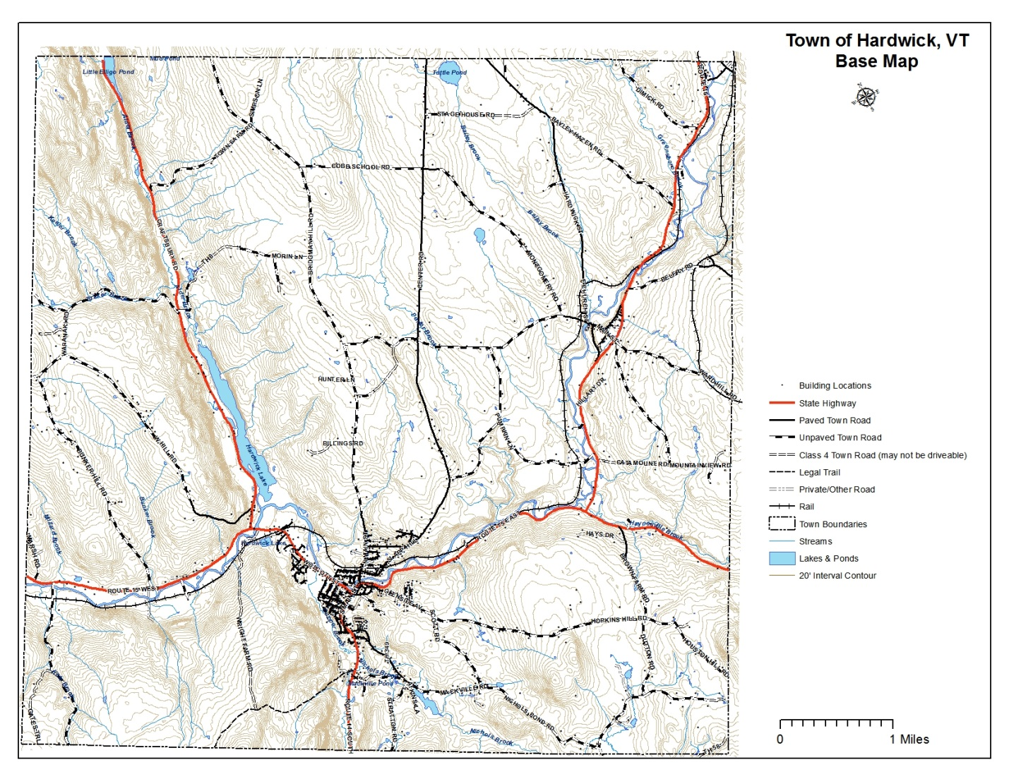

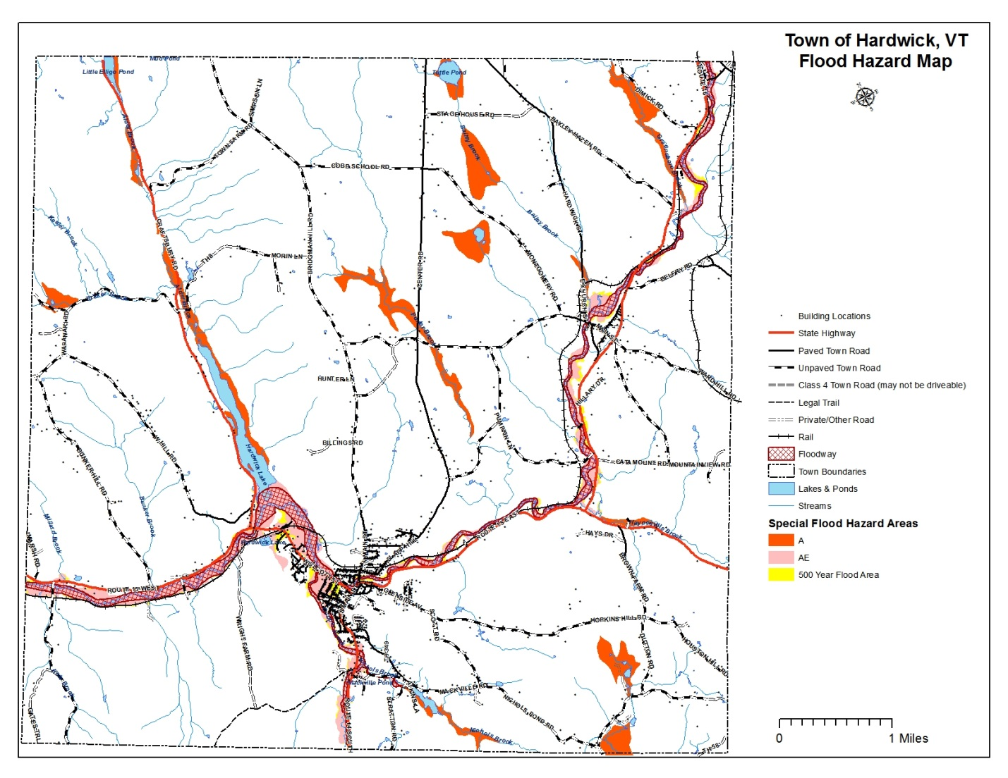

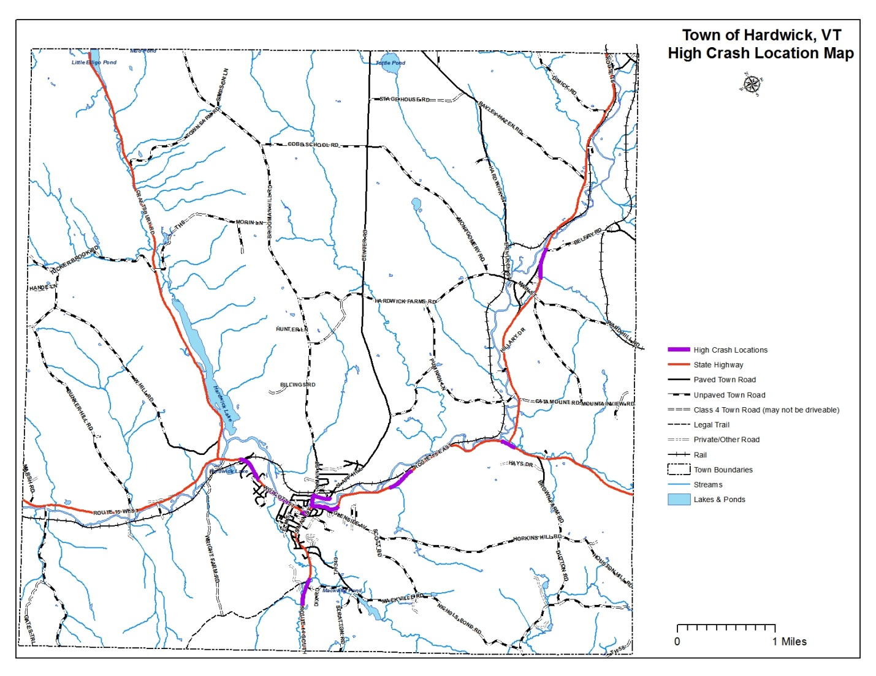

**Element D.**

**Plan Review, Evaluation and Implementation**

## Initial Plan Approval Procedures

In addition to local involvement in the initial development of the Hardwick AHMP, opportunities for public comment include approval of the plan at a public meeting of the Selectboard. The Local Emergency Planning Committee (LEPC) 9 received a presentation on the plan at one of their regular meetings. Following consideration of the comments from those entities, the draft plan was presented to the State Hazard Mitigation Committee through the State Hazard Mitigation Officer (SHMO) for review and comment and a recommendation for forwarding to FEMA Region I.

Following an affirmative recommendation for forwarding to FEMA Region I, the Hardwick All-Hazards Mitigation Plan will be presented to the Hardwick Selectboard for adoption.. The final plan will then be forwarded to FEMA Region 1 for formal approval.

**Implementation Schedule**

Local officials have identified two significant potential risks to the Town of Hardwick. The first threat is the ongoing ice build-up along the Lamoille River for approximately one mile west of the village area. The area is relatively flat and ice restricts the flow. The Town has spent over $40,098 in subcontracted, non-reimbursable expenses the last five winters dredging the ice from the river to prevent flooding in the village. The mitigation needs determined to have the highest priorities were the most cost effective and were the root cause of the ongoing flooding problems. Readiness and timeliness of project was also important. Several engineering techniques are being evaluated to for best practices to eliminate and remove ice buildup.

The second major threat is the potential contamination of the public water supply. This is a high yield municipal water source that is surrounded by a major highway, a potential

flood area, the Lamoille River, a shopping area, an industrial park, and a high accident location. An assessment of the source and extent of the water supply needs to be evaluated and then protected against a potential HazMat spill, other contamination and/or flooding. Potential hazardous material incidents are caused mainly by highway features combined with areas that typically flood. These areas are Vermont State highways which are the responsibility of the Vermont Agency of Transportation and are being evaluated by their engineers in conjunction with local officials.

The evaluating of these criteria is largely based on best available information and best judgment as many of the projects are not fully scoped out at this time. The actions are listed in the Table 3-B in order of importance, cost effectiveness and feasibility to the community. Actual detailed cost benefit analysis is dependent on additional studies for Needs 1,2 and 5. It is assumed that long-term benefits of understanding and possibly proceeding with mitigation for these measures far outweighs the cost of investigation and analysis. Need 3 is necessary for a better identification of risks and impacts to neighborhoods and structures, and to undertake Need 4. These are soft cost measures and the benefit is not easily monetized at this point in time.

The following identified programs, projects and activities listed in order of priority. Accurate mapping is considered essential if the Town wants to fully understand the scope of the flood hazard and such mapping will greatly assist in the development of emergency planning and any engineering necessary for additional mitigation.

**Plan Maintenance**

To ensure that the Hardwick All-Hazards Mitigation Plan remains current and relevant, it is important that it be updated periodically. The plan shall be updated every five years, pending ongoing financial resources, in accordance with the following procedures:

1. The Hardwick Selectboard will assess the needs of the town annually and evaluate the mitigation strategy. If revisions to the strategy are needed, the Selectboard will either act as a review committee or appoint a review committee.
2. The committee will discuss the process to determine if the evaluation criteria is still appropriate or modifications or additions are needed to the mitigation strategies based on changing conditions since the last update occurred. Data needs will be reviewed, data sources identified and responsibility for collecting information will be assigned to members.
3. The review committee will solicit public comment and public participation throughout the revision process.
4. A draft report will be prepared based on the evaluation criteria and in conformance with the FEMA Region I Local Hazard Mitigation Plan Crosswalk.
5. The Selectboard will have the opportunity to review the draft report. Consensus will be reached on changes to the draft.
6. The updated plan will be reviewed by Vermont Emergency Management (SHMO) staff and then FEMA Region I staff. Any comments or revisions recommended by FEMA and VEM will be incorporated into the draft.
7. Upon receiving Conditional Approval from FEMA, the Selectboard will warn the plan for approval at its regular meeting.
8. The Selectboard will finalize and adopt the updated plan and distribute to the Regional Planning Commission, Vermont Emergency Management, and FEMA Region 1.

Although the plan will be reviewed, pending ongoing financial resources, in its entirety every five years the town may review and update its programs, initiatives and projects more often based on the above procedure as changing needs and priorities arise.

**Element E.**

**Plan Adoption**

Adoption pending approval.

1. Tier II Data Reporting, Vermont Department of Public Safety.